Sitemap

🗺️ Final Sitemap: POS with Inventory Management (Tialo Japan Surplus)

1. Authentication
- Login (Admin / Cashier)
- Logout

2. POS Module
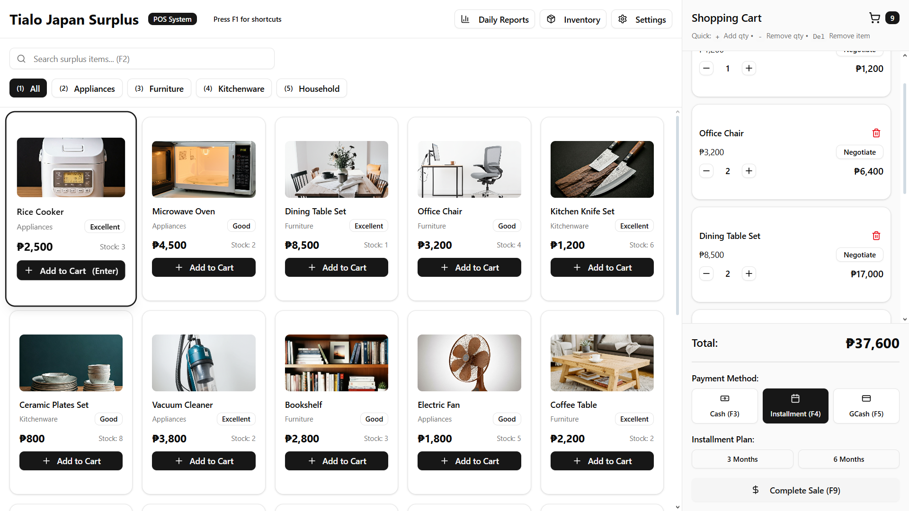
Cashier and Admin
- Product Search (manual, no scanner)
- Add to Cart
- Manual Price Discounts (for bargaining)
- Payment Options:
  - Cash
  - GCash
  - Installment (track due balances)
- Generate E Receipt
- View Today’s Transactions

3. Dashboard (Admin Only)
- Overview Cards:
  - Daily Sales
  - Inventory Summary (Low Stock Alerts)
  - Top Selling Products
- Quick Access Shortcuts to POS, Reports, Inventory

4. Inventory Management (Core Module)
SubTabs:
- Shipments
  - Acts like a folder for each incoming delivery.
  - Add Shipment includes:
    - Date & Time
    - Supplier
    - Driver’s Name
    - Total Boxes (count includes big items)
  - Once a shipment is created (like an empty folder), you can open it to add the products included in that shipment.
  - Supports:
    - Add / Edit / Delete Shipments
    - View all shipment records
- Main Products
  - Contains all products currently available for sale.
  - Admin can perform CRUD operations (Add, Edit, Delete, Update).
  - These products are the same ones displayed in the POS Module.
  - Includes:
    - Product ID
    - Name
    - Category
    - Quantity
    - Price
    - Status (Available / Sold / Out of Stock)

🧾 5. Reports (Admin Only)

1. Sales Reports
- View and filter by Daily / Weekly / Monthly
- Filter options:
  - Payment Type (Cash / GCash / Installment)
  - Staff / User
- Export options: PDF / Excel

2. Installment Reports
- List of ongoing installment transactions
- Show due dates and remaining balances
- Optional alert for overdue payments

3. Inventory Reports
- Current Stock Report (available products only)
- Low Stock Alert Report (below threshold items)
- Stock Movement Log (stock-in, stock-out, adjustments)

6. User Management
- Add / Edit / Deactivate Users (Admin / Staff)
- Role Assignment

🧍‍♂️ User Roles
- Admin: Full access (POS, Inventory, Reports,)
- Staff: Limited (POS + View Inventory only)

Proposed ERD

🧩 Entity Relationship Draft (Simplified)
1. Users
- user_id (PK)
- name
- email
- password
- role (Admin / Cashier)
2. Shipments
- shipment_id (PK)
- date_received
- time_received
- supplier (text input)
- driver_name
- total_boxes
3. Products
- product_id (PK)
- shipment_id (FK → Shipments.shipment_id)
- name
- category
- quantity
- price
- status (Available / Sold / Out of Stock)
4. Transactions
- transaction_id (PK)
- user_id (FK → Users.user_id)
- transaction_date
- payment_type (Cash / GCash / Installment)
- total_amount
5. Transaction_Items
- item_id (PK)
- transaction_id (FK → Transactions.transaction_id)
- product_id (FK → Products.product_id)
- quantity
- subtotal
6. Installments (optional for POS)
- installment_id (PK)
- transaction_id (FK → Transactions.transaction_id)
- due_date
- amount_due
- balance_remaining
- status (Paid / Unpaid)

📊 Relationships summary:
- Users → Transactions: one-to-many
- Shipments → Products: one-to-many
- Products → Transaction_Items: one-to-many
- Transactions → Transaction_Items: one-to-many
- Transactions → Installments: one-to-one or one-to-many

Next step:
Would you like me to visualize this as an ERD diagram (with connecting lines) or keep it as a table structure reference for now while you review it?

You said:
what are the shown table for every page?

ChatGPT said:
Good question, Zo — this part connects your ERD to the actual system pages, so you’ll know which tables each page reads from or writes to.
Here’s the full mapping based on your Final Sitemap 👇

🗺 Table–Page Mapping

1. Authentication (Login / Logout)
Tables:
- users → used to verify credentials (login)
Purpose:
Check user role (Admin or Cashier) to control access.

2. POS Module
Tables:
- products → show product list and prices
- transactions → store transaction headers (total, date, cashier)
- transaction_items → store product details inside a transaction
- installments → store installment payments (if payment type = installment)
- users → identify who made the sale
Flow:
User searches product → adds to cart → completes payment → system inserts records into transactions and transaction_items.

3. Dashboard (Admin Only)
Tables:
- transactions → for daily sales
- products → for low stock alerts
- transaction_items → for top-selling products
Flow:
Dashboard displays summaries from aggregated queries.

4. Inventory Management
A. Shipments Tab
Tables:
- shipments → main table for each incoming delivery
- products → linked products (added under each shipment)
Flow:
Add shipment → open shipment → add products → products saved under that shipment ID.
B. Main Products Tab
Tables:
- products → full list of all items currently for sale (CRUD operations).
Flow:
Any edit here reflects on what’s visible in the POS.

5. Reports (Admin Only)
Tables:
- transactions → sales summary
- transaction_items → sales by product
- products → inventory reports (stock level, movement)
- installments → installment report
Flow:
Admin filters data and exports reports (PDF/Excel).

6. User Management
Tables:
- users → manage system users (add, edit, deactivate).

So basically:
- Inventory pages → use shipments + products
- POS pages → use products, transactions, transaction_items
- Reports & Dashboard → read from all transaction-related tables

Want me to make a visual table-to-page map (like a matrix or chart) so you can use it in your documentation?

sql
-- Create database
CREATE DATABASE tialo_posdb;
USE tialo_posdb;

-- USERS TABLE
CREATE TABLE users (
user_id INT AUTO_INCREMENT PRIMARY KEY,
name VARCHAR(100) NOT NULL,
email VARCHAR(100) UNIQUE NOT NULL,
password VARCHAR(255) NOT NULL,
role ENUM('Admin', 'Cashier') NOT NULL
);

-- SHIPMENTS TABLE
CREATE TABLE shipments (
shipment_id INT AUTO_INCREMENT PRIMARY KEY,
date_received DATE NOT NULL,
time_received TIME NOT NULL,
supplier VARCHAR(100) NOT NULL,
driver_name VARCHAR(100),
total_boxes INT DEFAULT 0
);

-- PRODUCTS TABLE
CREATE TABLE products (
product_id INT AUTO_INCREMENT PRIMARY KEY,
shipment_id INT,
name VARCHAR(150) NOT NULL,
category VARCHAR(100),
quantity INT DEFAULT 0,
price DECIMAL(10,2) NOT NULL,
status ENUM('Available', 'Sold', 'Out of Stock') DEFAULT 'Available',
FOREIGN KEY (shipment_id) REFERENCES shipments(shipment_id)
ON DELETE SET NULL ON UPDATE CASCADE
);

-- TRANSACTIONS TABLE
CREATE TABLE transactions (
transaction_id INT AUTO_INCREMENT PRIMARY KEY,
user_id INT,
transaction_date DATETIME DEFAULT CURRENT_TIMESTAMP,
payment_type ENUM('Cash', 'GCash', 'Installment') NOT NULL,
total_amount DECIMAL(10,2) NOT NULL,
FOREIGN KEY (user_id) REFERENCES users(user_id)
ON DELETE SET NULL ON UPDATE CASCADE
);

-- TRANSACTION ITEMS TABLE
CREATE TABLE transaction_items (
item_id INT AUTO_INCREMENT PRIMARY KEY,
transaction_id INT,
product_id INT,
quantity INT NOT NULL,
subtotal DECIMAL(10,2) NOT NULL,
FOREIGN KEY (transaction_id) REFERENCES transactions(transaction_id)
ON DELETE CASCADE ON UPDATE CASCADE,
FOREIGN KEY (product_id) REFERENCES products(product_id)
ON DELETE SET NULL ON UPDATE CASCADE
);

-- INSTALLMENTS TABLE
CREATE TABLE installments (
installment_id INT AUTO_INCREMENT PRIMARY KEY,
transaction_id INT,
due_date DATE NOT NULL,
amount_due DECIMAL(10,2) NOT NULL,
balance_remaining DECIMAL(10,2) NOT NULL,
status ENUM('Paid', 'Unpaid') DEFAULT 'Unpaid',
FOREIGN KEY (transaction_id) REFERENCES transactions(transaction_id)
ON DELETE CASCADE ON UPDATE CASCADE
);

development plan

🧩 2. Module Breakdown (based on your sitemap)
Module | Main Pages | Related Tables
Authentication | Login, Logout | users
POS | Cart, Checkout, Receipt | transactions, transaction_items, products, installments
Dashboard | Overview, Stats | transactions, products
Inventory Management | Shipments, Main Products | shipments, products
Reports | Sales, Installments, Inventory | All transaction-related tables
User Management | Manage Users | users

🗓 3. Development Timeline (Sprint Plan Example)
Week | Tasks | Output
1 | Database setup & connection config | Working DB + PHP connection
2 | Authentication module | Working login/logout with user roles
3 | Inventory Management (Shipments + Products CRUD) | Add/edit/delete shipment & product
4 | POS Module | Cart system, payment options, receipt
5 | Reports + Dashboard | Summary cards & report filters
6 | User Management | Admin adds/deactivates staff
7 | Testing + Deployment prep | Final bug checks, online upload

Structure
htdocs/
│
└── tialo_pos/
├── assets/
│ ├── css/
│ ├── js/
│ └── img/
│
├── includes/
│ ├── db_connect.php ← database connection
│ ├── header.php ← navbar/topbar
│ ├── footer.php
│ └── auth_check.php ← session role check
│
├── modules/
│ ├── auth/ ← login/logout
│ ├── pos/ ← cart, checkout
│ ├── inventory/ ← shipments, products
│ ├── reports/
│ ├── dashboard/
│ └── users/
│
├── index.php ← landing/login redirect
└── dashboard.php

REFERENCE
https://tialosurplus.vercel.app

